Department of Computer Science and Engineering
University of Barishal
Theory of Computation — Mid-Term Exam (16 June 2026)
Model Solutions | Total 60 Marks | Instructor: Dr. Md Manjur Ahmed

Question Index by Topic
Q | Topic | Sub-topic | Marks
1 | Regular Expressions & Finite Automata | Kleene’s Theorem (RE ⇒ FA), Thompson’s construction, structural induction | 10
2 | Closure Properties of Regular Languages | Closure under complementation (DFA construction) | 10
3 | Finite Automata | NFA → DFA conversion by subset construction | 10
4 | Regular Expressions & Finite Automata | RE → ε-NFA conversion (Thompson’s construction) | 10
5 | ε-NFA (Finite Automata with ε-moves) | Role/importance of ε-transitions, ε-closure, equivalence with NFA/DFA | 10
6 | ε-NFA Design | Building an ε-NFA for a given language (union / concatenation of languages) | 10

Notation. Σ = alphabet; Σ* = all strings over Σ; ε = empty string; ∅ = empty language; δ = transition function; δ* = extended transition function; L(M) = language accepted by machine M; ε-closure(q) = set of states reachable from q using only ε-moves.

Question 1 — Every regular expression language is accepted by a finite automaton
Marks | 10
Topic | Regular Expressions & Finite Automata
Sub-topic | Kleene’s Theorem, Part 1 (RE ⇒ FA)
Key technique | Structural induction on the regular expression + Thompson’s construction

Theorem. If R is a regular expression over Σ, then there is an ε-NFA M with L(M) = L(R). (Since every ε-NFA can be converted to an equivalent NFA and then a DFA, L(R) is accepted by a finite automaton.)
Proof (by structural induction on R). We build an ε-NFA M with exactly one start state, exactly one final state, no transitions into the start state and no transitions out of the final state.

Basis (the three atomic expressions)
- R = ∅: M has start state q₀ and final state q_f and no transitions, so L(M) = ∅.
- R = ε: one ε-transition q₀ → q_f, so L(M) = {ε}.
- R = a (a ∈ Σ): one transition q₀ —a→ q_f, so L(M) = {a}.
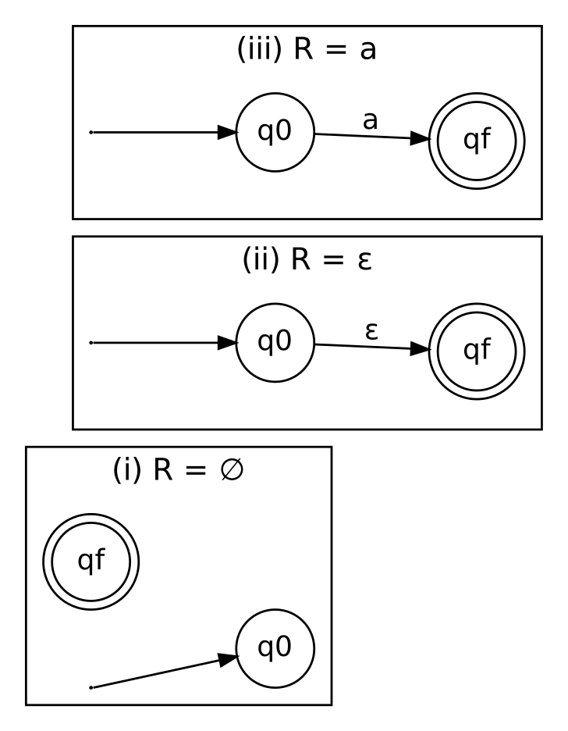
Figure 1.1: Automata for the basis expressions ∅, ε and a

Inductive step
Hypothesis: R₁ and R₂ have ε-NFAs M₁ = (Q₁,Σ,δ₁,s₁,{f₁}) and M₂ = (Q₂,Σ,δ₂,s₂,{f₂}) with L(Mᵢ) = L(Rᵢ), and Q₁ ∩ Q₂ = ∅ (rename states if needed).
Case 1 — Union, R = R₁ + R₂. Add a new start state q₀ and a new final state q_f. Add ε-moves q₀ → s₁, q₀ → s₂, f₁ → q_f, f₂ → q_f.
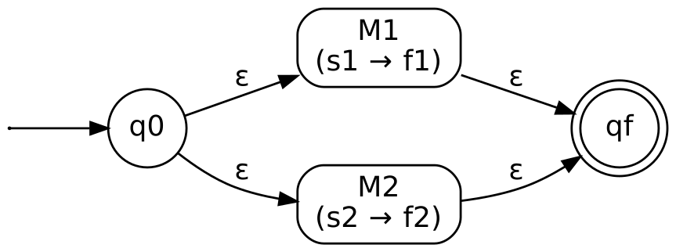
Figure 1.2: Union construction
Any accepting path goes q₀ → s₁ ⇝ f₁ → q_f or q₀ → s₂ ⇝ f₂ → q_f, hence it reads a string of L(R₁) or of L(R₂). Conversely every such string has an accepting path. So L(M) = L(R₁) ∪ L(R₂) = L(R₁ + R₂).
Case 2 — Concatenation, R = R₁R₂. Keep s₁ as the start state and f₂ as the final state; add one ε-move f₁ → s₂.
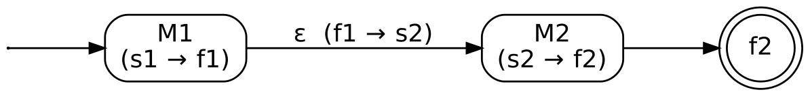
Figure 1.3: Concatenation construction
An accepting path must pass through the ε-move f₁ → s₂ (the only link between the two machines), so w = xy with x ∈ L(R₁) read before the move and y ∈ L(R₂) read after it. Hence L(M) = L(R₁)·L(R₂) = L(R₁R₂).
Case 3 — Kleene star, R = R₁*. Add a new start q₀ and new final q_f with ε-moves q₀ → s₁, f₁ → q_f, q₀ → q_f (accepts ε) and f₁ → s₁ (repeat).
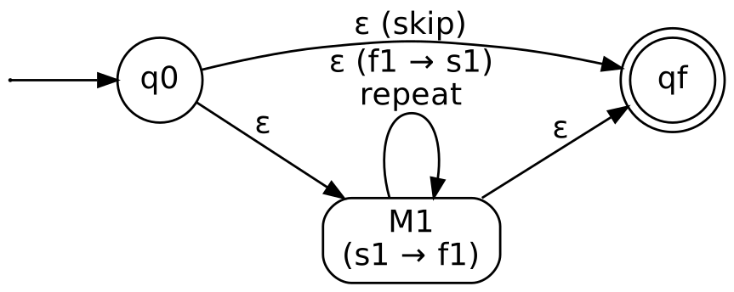
Figure 1.4: Kleene-star construction
Going around the loop f₁ → s₁ k times reads k strings of L(R₁), so L(M) = ⋃ₖ≥₀ L(R₁)ᵏ = L(R₁)* = L(R₁*) (k = 0 uses the skip edge q₀ → q_f, giving ε).
Conclusion. Every regular expression is built from ∅, ε, a using +, concatenation and *, and each step yields an ε-NFA with the same language. By induction, L(R) is accepted by an ε-NFA, which (via ε-closure elimination and subset construction) is equivalent to a DFA. ∎

Question 2 — Complement of a regular language is regular
Marks | 10
Topic | Closure Properties of Regular Languages
Sub-topic | Closure under complementation
Key technique | Complete the DFA, then swap final and non-final states

Claim. If L is regular over Σ, then L̄ = Σ* − L is regular.
Proof. Since L is regular, there is a DFA M = (Q, Σ, δ, q₀, F) with L(M) = L. We may assume M is complete: δ(q,a) is defined for every q ∈ Q and a ∈ Σ. (If not, add a non-final dead/trap state d with δ(d,a) = d for all a and send every missing transition to d; the language is unchanged.)
Define the DFA
M′ = (Q, Σ, δ, q₀, Q − F)
i.e. same states, alphabet, transitions and start state, but with accepting and non-accepting states interchanged.
Take any w ∈ Σ*. Because M is deterministic and complete, δ*(q₀, w) is exactly one state. Then:
w ∈ L(M′) ⇔ δ*(q₀, w) ∈ Q − F ⇔ δ*(q₀, w) ∉ F ⇔ w ∉ L(M) ⇔ w ∈ Σ* − L
Hence L(M′) = Σ* − L = L̄. As L̄ is accepted by a DFA, it is regular. ∎
Illustration. Let Σ = {0,1} and L = strings ending in 0. Swapping the final status of p and q gives the DFA for the strings that are empty or end in 1.
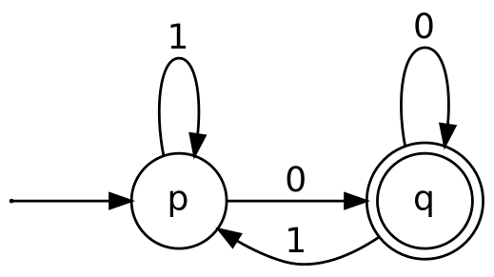
Figure 2.1: DFA M for L (strings ending in 0)
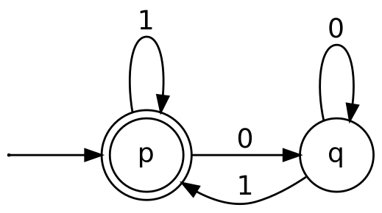
Figure 2.2: DFA M′ for L̄ (ε and strings ending in 1)
Remark (why completeness and determinism matter). The swap trick fails for an NFA: a string may have both accepting and rejecting paths, so after swapping it could still be accepted. Likewise, a missing transition (implicit dead state) would make strings that die in M be rejected in M′ too, instead of accepted. That is why we first complete the DFA.

Question 3 — Convert the NFA to a DFA
Marks | 10
Topic | Finite Automata (Nondeterminism)
Sub-topic | NFA → DFA conversion (subset construction)
Key technique | Build DFA states as subsets of NFA states, starting from {q₀}

Reading of the given NFA. Σ = {a,b}, start state 0, states {0,1,2,3}. From the figure: 0 —a→ 1, 0 —a→ 2; 1 —a→ 1 (loop), 1 —a→ 3, 1 —b→ 2; 2 —a→ 1, 2 —b→ 3; 3 —a→ 2. States 0, 1, 2 are drawn with double circles (final); state 3 is not. (Please compare with your question paper: if the final states differ, only the final-state marking in Step 3 changes; the transitions of the DFA stay identical.)
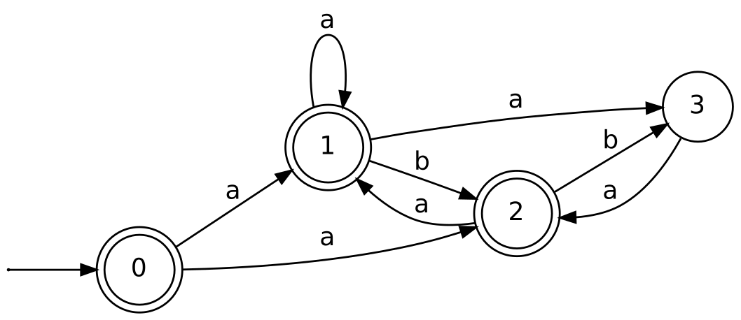
Figure 3.1: The given NFA (as read from the question paper)

Step 1: NFA transition table
State | δ(q, a) | δ(q, b)
→ *0 | {1, 2} | ∅
* 1 | {1, 3} | {2}
* 2 | {1} | {3}
3 | {2} | ∅

Step 2: Subset construction
Start with A = {0}. For each new subset S compute δ′(S,x) = ⋃ δ(q,x) over q ∈ S, until no new subsets appear.
DFA state | NFA subset | On a | On b | Final?
A | {0} | a → {1,2} = B | b → ∅ = D | Yes (0 ∈ F)
B | {1,2} | a → {1,3}∪{1} = {1,3} = C | b → {2}∪{3} = {2,3} = E | Yes
C | {1,3} | a → {1,3}∪{2} = {1,2,3} = F | b → {2}∪∅ = {2} = G | Yes
E | {2,3} | a → {1}∪{2} = {1,2} = B | b → {3}∪∅ = {3} = H | Yes
F | {1,2,3} | a → {1,3}∪{1}∪{2} = {1,2,3} = F | b → {2}∪{3}∪∅ = {2,3} = E | Yes
G | {2} | a → {1} = I | b → {3} = H | Yes
H | {3} | a → {2} = G | b → ∅ = D | No
I | {1} | a → {1,3} = C | b → {2} = G | Yes
D | ∅ (dead) | a → D | b → D | No

Step 3: Final states
A DFA state is final iff its subset contains at least one NFA final state (0, 1 or 2). Hence F′ = {A, B, C, E, F, G, I}; the only non-final states are H = {3} and the dead state D = ∅.

Step 4: Resulting DFA
M′ = (Q′, {a,b}, δ′, A, F′) with Q′ = {A,B,C,D,E,F,G,H,I} (9 of the 2⁴ = 16 possible subsets are reachable).
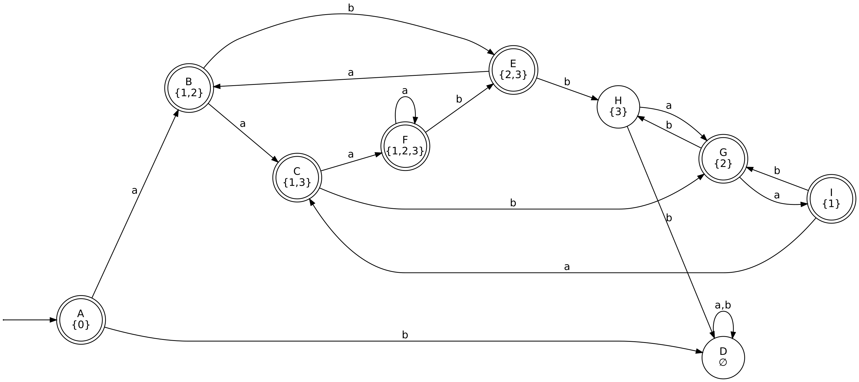
Figure 3.2: Equivalent DFA obtained by subset construction

Question 4 — RE to ε-NFA: (0+1)*01(0+1)*
Marks | 10
Topic | Regular Expressions & Finite Automata
Sub-topic | RE → ε-NFA conversion
Key technique | Thompson’s construction (union, concatenation, star)

Step 1 — Decompose the expression. R = A · 0 · 1 · A, where A = (0+1)*. The language is all binary strings that contain 01 as a substring.
Step 2 — Build the pieces.
- Machines for the symbols 0 and 1 (basis case, one edge each).
- 0 + 1: new start, ε-moves to the 0-machine and the 1-machine, both ε-moves to a new final state (union).
- (0+1)*: add ε-moves final → start (repeat) and new start → new final (accept ε) (star).
- Concatenate A, the 0-machine, the 1-machine and a second copy of A with ε-links (concatenation).
Step 3 — Final ε-NFA. The first copy of (0+1)* uses states 0–7, the symbols 0 and 1 use states 8–11, and the second copy of (0+1)* uses states 12–19. Start state = 0, final state = 19.
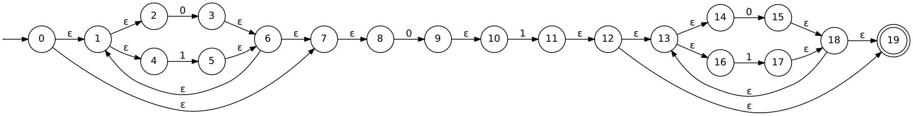
Figure 4.1: ε-NFA for (0+1)*01(0+1)* (Thompson’s construction)

Verification
Test w = 1001: 0 →ε 1 →ε 4 —1→ 5 →ε 6 →ε 1 →ε 2 —0→ 3 →ε 6 →ε 7 →ε 8 —0→ 9 →ε 10 —1→ 11 →ε 12 →ε 19. Accepted since it contains 01. The string 110 cannot pass the 8–11 segment (needs 0 then 1 consecutively after leaving the first loop), so it is rejected.
Note: In an exam you may also draw the shortened version (merging the ε-linked states 7,8 and 11,12), which accepts the same language.

Question 5 — Why are explicit ε-transitions important?
Marks | 10
Topic | ε-NFA (Finite Automata with ε-moves)
Sub-topic | Role of ε-transitions, ε-closure, equivalence of ε-NFA, NFA and DFA
Key technique | Conceptual explanation with ε-closure definition

Definition. An ε-NFA is a 5-tuple (Q, Σ, δ, q₀, F) where δ : Q × (Σ ∪ {ε}) → 2^Q. The machine may change state without reading any input symbol.
ε-closure. ε-closure(q) is the set of states reachable from q using zero or more ε-moves; ε-closure(S) = ⋃ ε-closure(q) for q ∈ S. The extended function is δ̂(q,ε) = ε-closure(q) and δ̂(q,wa) = ε-closure( ⋃ δ(p,a) for p ∈ δ̂(q,w) ).

Why ε-transitions are important
- Modular, compositional design. Smaller automata can be glued together with ε-links without disturbing their internals. This is exactly what Thompson’s construction does for union, concatenation and star (Question 1).
- Proving closure properties. Regular languages are closed under union, concatenation and Kleene star; the proofs become simple with ε-moves (one new start state with ε-edges to both machines, etc.).
- Bridge between RE and automata. They give a direct, mechanical translation of every regular expression into an automaton (Kleene’s theorem), which is used in lexical analyzers, compilers, and pattern matchers (grep, regex engines).
- Compactness and readability. A single ε-edge can replace many parallel transitions, so ε-NFAs are usually smaller and easier to design and verify than equivalent NFAs, especially for languages like {ε} ∪ Σ*01 (Question 6).
- Natural way to express choices and the empty string. Nondeterministic “guess” points and acceptance of ε are expressed directly, without extra bookkeeping.

They add convenience, not power
Every ε-NFA can be converted to an equivalent NFA without ε-moves: the new transition function is δ′(q,a) = ε-closure( δ( ε-closure(q), a ) ), and q becomes final if ε-closure(q) ∩ F ≠ ∅. The NFA can then be converted to a DFA by subset construction. Hence
L(DFA) = L(NFA) = L(ε-NFA) = L(RE) = class of regular languages.
Conclusion. Explicit ε-transitions do not enlarge the class of recognizable languages, but they make constructing, combining and reasoning about finite automata far easier, which is why they are central to the theory (Kleene’s theorem) and to practical tools.

Question 6 — ε-NFA for L = { w | w is empty, or if non-empty ends in 01 }
Marks | 10
Topic | ε-NFA Design
Sub-topic | Building an ε-NFA for a language given by a verbal property
Key technique | Express L as a union: L = {ε} ∪ Σ*01, with Σ = {0,1}

Step 1 — Analyse the language. L = {ε} ∪ {w ∈ {0,1}* : w ends in 01} = {ε} ∪ (0+1)*01.
Step 2 — Design. Use two parallel branches from the start state q₀ via ε-moves:
- Branch 1 (empty string): q₀ —ε→ q₃, where q₃ is final. This accepts ε.
- Branch 2 (ends in 01): q₀ —ε→ q₁; q₁ loops on 0,1 (any prefix); then q₁ —0→ q₂ —1→ q₃.
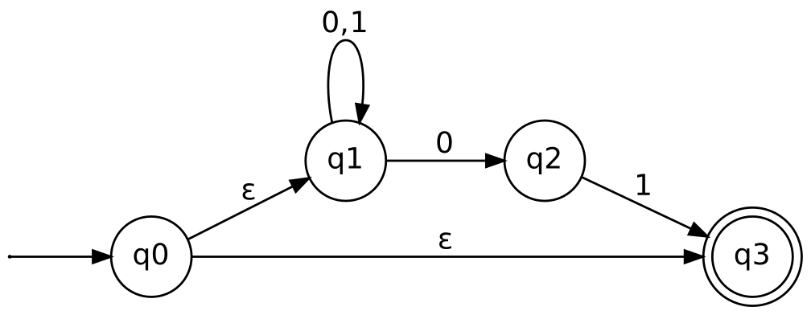
Figure 6.1: ε-NFA for {ε} ∪ Σ*01
Formal definition. N = (Q, Σ, δ, q₀, F), Q = {q₀,q₁,q₂,q₃}, Σ = {0,1}, F = {q₃}, with δ:
State | 0 | 1 | ε
→ q₀ | ∅ | ∅ | {q₁, q₃}
q₁ | {q₁, q₂} | {q₁} | ∅
q₂ | ∅ | {q₃} | ∅
* q₃ | ∅ | ∅ | ∅

Step 3 — Testing
Input | Path | Result
ε | q₀ →ε q₃ | Accept
01 | q₀ →ε q₁ —0→ q₂ —1→ q₃ | Accept
1101 | q₀ →ε q₁ (1,1) q₁ —0→ q₂ —1→ q₃ | Accept
0 | q₀ →ε q₁ —0→ q₂ (stuck, not final) | Reject
10 | can only reach q₁ or q₂, never q₃ | Reject
011 | q₂ —1→ q₃ but input remains; q₃ has no moves | Reject

Conclusion. The automaton accepts exactly ε and the strings ending in 01, i.e. L(N) = {ε} ∪ Σ*01 = L. ∎

